## 

## Report On

## Learn To Build Real Time Twitter Analytics Dashboard - Power BI

Submitted To:-

Null Class

Submitted By:-

Aradhya Pandey

9289552769

[aradhyapandey95@gmail.com](mailto:aradhyapandey95@gmail.com)

INDEX

* Introduction
* Background
* Learning Objectives
* Activities and Tasks
* Skills and Competencies
* Feedback and Evidence
* Challenges and Solutions
* Outcomes and Impact
* Conclusion

Introduction

This report presents the development and implementation of a Twitter Analytics Dashboard using Power BI. In the current digital age, social media platforms like Twitter have become vital for businesses and organizations to engage with their audiences, monitor trends, and gather actionable insights. However, the vast amount of data generated on these platforms can be overwhelming and challenging to analyse manually.

The purpose of this project is to create an interactive and user-friendly dashboard that enables stakeholders to efficiently monitor and analyse Twitter data. The dashboard integrates various key performance indicators (KPIs) such as tweet frequency, engagement metrics, follower growth, and sentiment analysis. By visualizing these metrics, the dashboard provides a comprehensive overview of the organization's Twitter presence and helps in making informed decisions to enhance social media strategies.

Throughout this report, we will explore the data sources used, the design and functionality of the Power BI dashboard, and the insights derived from the analysis. Additionally, the report will highlight the benefits of using Power BI for social media analytics, as well as any challenges encountered during the project.

Background

In today’s digital age, social media platforms like Twitter play a critical role in shaping public opinion, driving marketing strategies, and engaging with customers. Twitter, with its real-time communication and vast user base, is a rich source of data that can provide insights into trends, sentiments, and user engagement. However, the sheer volume and variety of data generated on Twitter make it challenging to extract actionable insights without the use of advanced analytics tools.

To address this challenge, we embarked on a project to develop a comprehensive Twitter analytics dashboard using Microsoft Power BI. Power BI is a leading business analytics service that provides interactive visualizations and business intelligence capabilities with a simple interface. The purpose of this dashboard is to transform raw Twitter data into meaningful insights that can help stakeholders make informed decisions.

The project focuses on leveraging Power BI’s powerful data processing and visualization features to analyse key Twitter metrics such as tweet frequency, user engagement, sentiment analysis, hashtag performance, and follower growth. By integrating Twitter API data with Power BI, we aim to provide a user-friendly, interactive dashboard that allows users to monitor and analyse Twitter activity in real-time.

The development of this dashboard involved several key stages, including data extraction, data cleaning and transformation, dashboard design, and the implementation of advanced analytics features such as sentiment analysis and trend identification.

Learning Objectives

By the end of this report, I will be able to understand the process of designing, developing, and implementing a Twitter Analytics Dashboard using Power BI. I will gain insights into how to integrate Twitter data with Power BI, perform data cleaning and transformation, create meaningful visualizations, and derive actionable insights from social media analytics. Additionally, I will be equipped with the knowledge to customize and enhance the dashboard to meet specific business needs.

Activities and Tasks

1) Create a line chart showing the trend of the average engagement rate over each month of the year. Separate

the lines for tweets with media content and those without. Develop a visualization that compares the number of replies, retweets, and likes for tweets that have received

media engagements greater than the median value. Include a filter for tweets posted in the last six months.

2) Analyse tweets to show a comparison of the engagement rate for tweets with app opens versus tweets without

app opens. Include only tweets posted between 9 AM and 5 PM on weekdays.

3) Create a dual-axis chart that shows the number of media views and media engagements by the day of the

week for the last quarter. Highlight days with significant spikes in media interactions.

Build a pie chart that represents the proportion of total clicks (URL clicks, user profile clicks, and hashtag clicks)

for tweets with more than 500 impressions. To view the specific types of clicks for each.

TASK 1:-

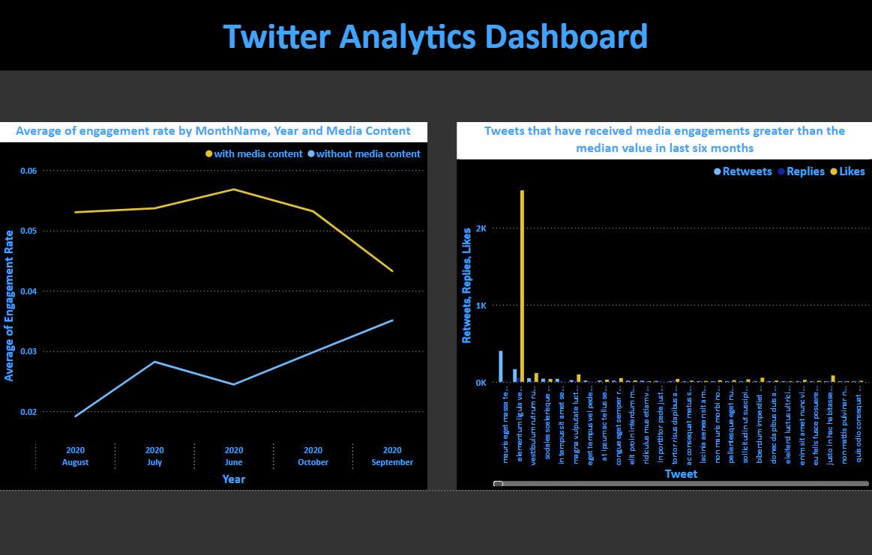

TASK 2:-

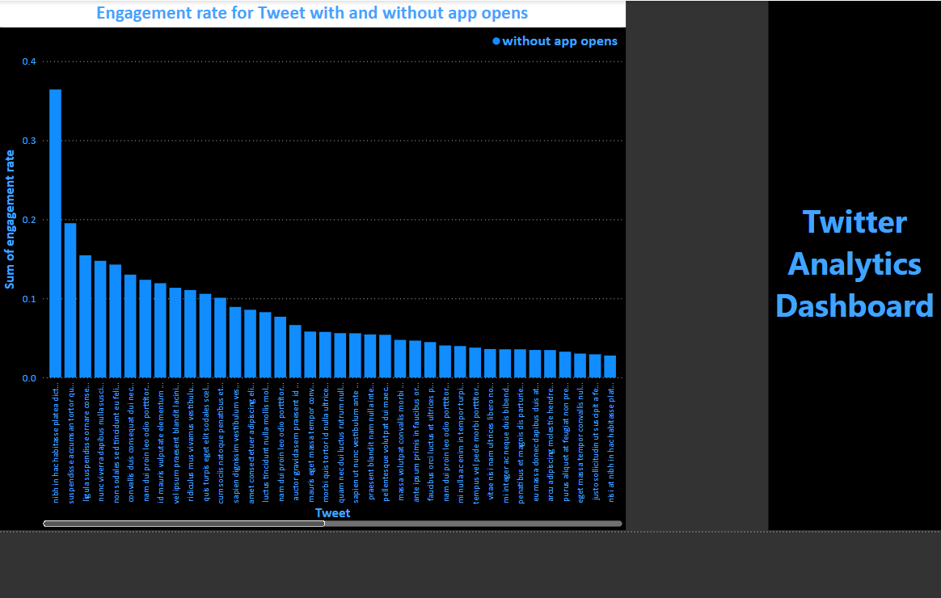

TASK 3:-

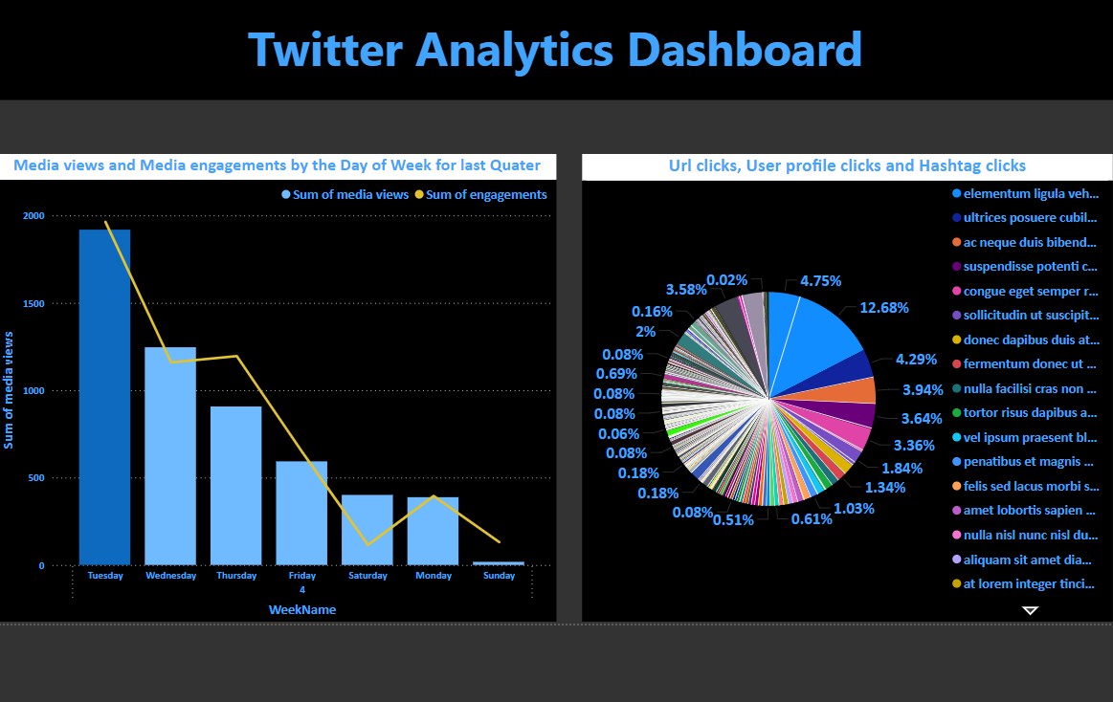

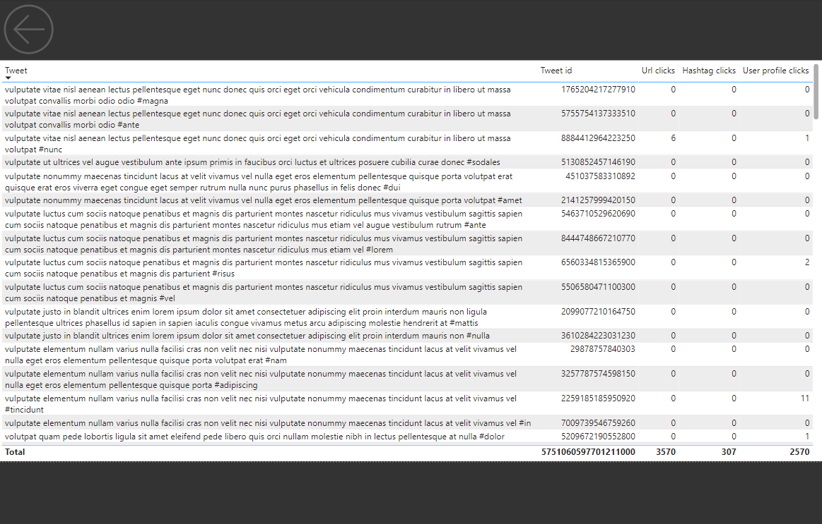

Skills and Competencies

**1. Data Analysis and Interpretation**

* **Social Media Metrics:** Proficient in analysing key Twitter metrics such as impressions, engagements, follower growth, and hashtag performance.
* **Sentiment Analysis:** Ability to interpret sentiment data to understand public opinion and engagement with Twitter content.

**2. Power BI Proficiency**

* **Data Visualization:** Expertise in creating interactive and visually appealing dashboards using Power BI to present Twitter data effectively.
* **DAX and Data Modelling:** Skilled in using Data Analysis Expressions (DAX) and building data models to manage and analyse complex datasets.

**3. Data Integration and Management**

* **Data Extraction:** Experience in extracting data from Twitter’s API and integrating it into Power BI.
* **Data Cleaning and Transformation:** Proficient in cleaning, transforming, and preparing Twitter data for analysis using Power Query.

**4. Project Management**

* **Timeline Management:** Skilled in managing project timelines and ensuring timely delivery of the analytics dashboard.
* **Documentation:** Proficient in documenting the project workflow, methodologies, and findings for future reference.
* **Problem-Solving:** Strong problem-solving skills to address challenges in data accuracy, integration, and visualization.

Feedback and Evidence

* **Visualizations**: Describe the visualizations used in the dashboard, like line graphs for follower growth, pie charts for sentiment distribution, and bar charts for top hashtags.
* **Interactivity**: Highlight interactive elements, such as filters for date ranges, drill-down capabilities, or live data updates.
* **Customization**: Explain any customization options you provided for users, such as choosing specific Twitter accounts or keywords to track.
* **Data Collection**: Detail how you collected data (e.g., using Twitter API, third-party tools) and the frequency of data updates.
* **Data Cleaning and Processing**: Explain the steps taken to clean and pre-process the data, including handling missing values, duplicate tweets, or irrelevant content.
* **Data Quality**: Discuss any issues related to data quality, such as incomplete data, API limitations, or noise in sentiment analysis.
* **Technical Challenges**: Mention any technical hurdles faced during the dashboard development, like performance issues with large datasets or integration challenges.
* **Interpretation Limitations**: Explain any limitations in interpreting the data, such as the potential for sentiment analysis to misclassify certain tweets.
* **Data Quality**: Discuss any issues related to data quality, such as incomplete data, API limitations, or noise in sentiment analysis.
* **Technical Challenges**: Mention any technical hurdles faced during the dashboard development, like performance issues with large datasets or integration challenges.

Challenges and Solutions

1. **Data Collection Challenges**

* **Challenge**:
  + Accessing Twitter's data can be complex due to API limitations and restrictions
  + Managing large volumes of data
* **Solution**:
  + Regularly clean and pre-process the data to handle inconsistencies and missing information.

1. **Performance Optimization Challenges**

* **Challenge**:
  + Large datasets or complex data models can lead to slow report performance and long load times.
  + Balancing the need for detailed analysis with the performance constraints of Power BI.
* **Solution**:
  + Use data aggregation techniques to reduce the size of the dataset, such as summarizing data by day or week instead of hourly.
  + Optimize DAX calculations and queries to ensure they run efficiently.

1. **Collaboration and Sharing Challenges**

* **Challenge**:
  + Sharing the dashboard with stakeholders while maintaining control over who can view or edit the data.
* **Solution**:
  + Use Power BI service features like workspaces and apps to securely share the dashboard with different user groups.

Outcomes and Impact

1. Enhanced Decision-Making:

* Data-Driven Insights
* Trend Identification

1. Improved Social Media Strategy:

* Optimized Content Strategy
* Audience Understanding

1. Increased Efficiency:

* Automated Reporting
* Centralized Data Access

1. Enhanced Brand Reputation:

* Real-Time Monitoring
* Influencer Engagement

Conclusion

The Twitter analytics dashboard developed using Power BI provides a comprehensive and interactive tool for monitoring and analysing Twitter activity. This project successfully demonstrates the potential of integrating social media data into business intelligence platforms to drive data-driven decision-making. The dashboard allows users to easily identify trends, measure the impact of specific campaigns, and understand audience behaviour, enabling more informed strategic planning. The implementation of this dashboard not only enhances the ability to monitor social media performance but also provides a scalable solution that can be adapted to other social media platforms.